

Robert B. Aardema, Esquire
Aardema, Whitelaw & Sears-Ewald, PLLC
5360 Cascade Road
Grand Rapids, MI 49546

Re: Hurley v. Lakeland, et al
Invoice No. 132233

Dear Mr. Aardema:

This certified letter is being issued to you in regards to your past due account in the amount of $ 112.00 that is 50 days past due, in the above-referenced case. We have made numerous attempts to collect for services rendered. As of yet, we have not been contacted by you or your office to make payment arrangements.
If we do not receive your total payment within ten days, we will have no recourse but to take the appropriate legal action necessary.
Sincerely,
Axiom Requisition Copy Service
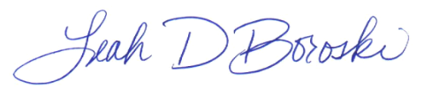

Leah D. Boroski
President

Enclosures

